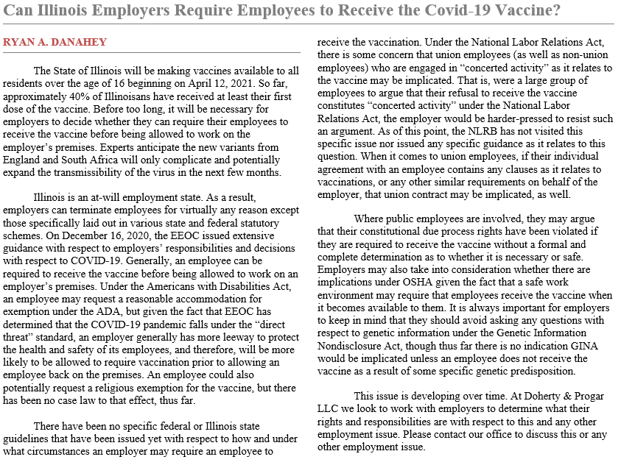



|  |  |
| --- | --- |
|  |  |

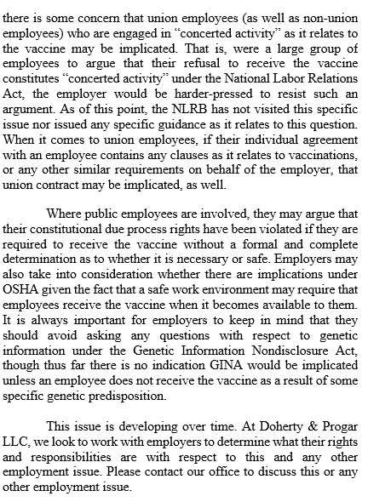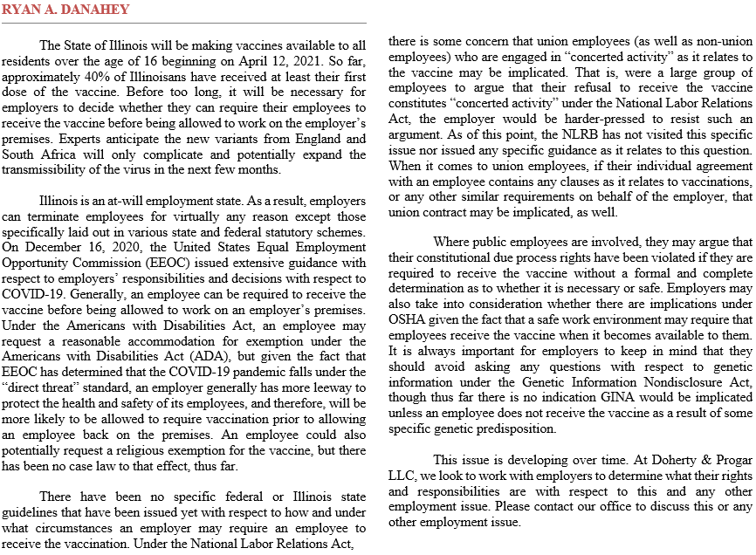

**Doherty & Progar LLC**

**www.doherty-progar.com**

**200 West Adams Street • Suite 2220 • Chicago, IL 60606 • P: 312-630-9630 • F: 312-630-9001**

**1251 North Eddy Street • Suite 200 • South Bend, IN 46617 • P: 219-513-9000 • F: 219-513-9010**

**250 East Wisconsin Avenue • Suite 1800 • Milwaukee, WI 53202 • P: 414-347-9600 • F: 414-347-9611**

,